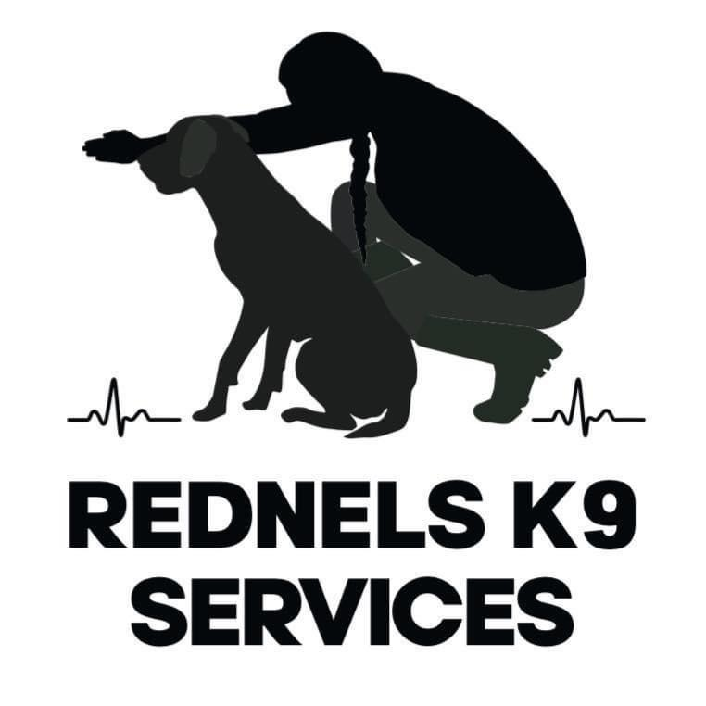

Rednels K9 Services Terms and Conditions;

The following terms and conditions are effective 1st January 2025- 1st January 2026

Between:

Rednels K9 kennels
Shannon Slender
Three oaks,
Blackmoor Row,
Shipdham,
IP25 7PU
License number:AWL0139
Insurance number;ACE005005

And; Custumer.
Clients Full name;

Clients full address;

Clients email address;

Your dog(s) Name:

Please read these terms and conditions before using our service.
These terms and conditions are in place to ensure the sustainability of our business, and to continue to provide a viable and professional service to you and your dogs in the future.

These terms and conditions stated bellow constitute a legally binding agreement between Shannon Slender at Rednels K9 services and ( Client name ). This agreement can be used as a legal documentation if further action is required.

- Rednels K9 services provided;
Rednels K9 services shall perform the services in a professional, attentive, reliable and caring manner, using her qualifications, knowledge, skills and care to provide the best care to clients dogs.
Rednels K9 services shall be responsible for ensuring that the facilities that your dog are boarding in are up to date and in line with the relevant licencing, regulations, byelaws, standards, code of conduct and any other rules and requirements relevant to the provision of Services.
By signing here I agree to the Services provided stated above;
Rednels K9 services customer’s obligations;
The Customer shall read and agree to follow the pertinent information in the Terms and Conditions in this documentation.
The Customer shall use all reasonable endeavours to provide full and accurate information to Rednels K9 services necessary for Rednels K9 services to provide Services.
The Customer authorises Rednels K9 Services to carry out the Services.
The Customer agrees that the information provided to Rednels K9 Services is true to the best of their information, knowledge and belief.
The Customer may issue reasonable instructions to Rednels K9 Services in relation to Rednels K9 Services’ provision of Services. Any such instructions should be compatible with the specification of Services.
By signing here I agree to the customer’s obligations provided stated above;
- Data Protection and Privacy
Personal information shared with Rednels K9 Services for the purpose of using Services will not be sold or shared with third parties, in accordance with GDPR 2018 (or subsequent revision). Information is held on paper and electronically for periods required by The Animal Welfare (Licensing of Activities Involving Animals) (England) Regulations 2018 and HMRC.
In accordance with GDPR, the Customer gives Rednels K9 Services permission to share information from this signed Agreement with Veterinary Practices as is necessary to provide care, and gives the Veterinary Practice permission to discuss pet care with Rednels K9 Services where the Customer is not able to be contacted.
Customers are advised that Rednels K9 Services may take and use photographs of pets for marketing purposes; however no specifics pertaining to the location of the pet or the owner will be divulged publicly. If you do not wish Rednels K9 Services to use photos of your pet for marketing purposes, please tell us via email at Rednelsk9services@outlook.com if you wish for photos not to be taken of your dogs.
In accordance with GDPR, the Customer gives Rednels K9 Services permission to share information to Breckland council when routine inspections are taking place to ensure that the correct paperwork is being documented to be in accordance with Animal Welfare (Licensing of Activities Involving Animals) (England) Regulations 2018.
By signing here I agree to Data Protection and Privacy policy stated above;
Rednels K9 services booking and cancellation Policy;
Bookings discussions shall not be considered as ‘confirmed’ until Rednels K9 services provides the Customer with a booking form and the Customer returns the booking form, a copy of your dogs up to date vaccination record and pays the deposit.

A meet and greet must take place before bookings are confirmed.
Your dog(s) must attend this meet and greet, to ensure your dog is happy here but also so I can behaviourally assess your dog to make sure I think they will be happy staying here to. The most important thing is making sure your dog’s stay is a positive one so they are happy to keep coming back.

A Booking forms must be signed and returned before your dog’s stay along with a copy of your dogs up to date vaccination records.
I need this booking for my licensing, and for safety for your dog. If I do not have booking form, then your booking can not be confirmed.

Rednels K9 services requires 50% deposit before any booking is confirmed. This is a Non refundable deposit.
Rednels K9 services states if you cancel your dogs booking over 3 months before the day of arrival of your dogs booking. 50% of the booking required as a deposit is non refundable. This is non negotiable.
Rednels K9 services states if you cancel your dogs booking within the 3months period of the day of arrival of your dogs booking. You are liable for the FULL (100%) amount of the fees. This is non negotiable.
For example;
Example 1;
It’s January 12th. Your dog is due to come in on June 12th until 15th June and you would like to cancel your dogs stay. You are liable for 50% of the TOTAL booking
Fee. 12th June - 15th June is 4 days. 4 x £35 = £140.00
50% of this is £70.00. So you are liable to pay £70.00.
Example 2;
It’s April 25th. Your dog is due to come in on June 12th until 15th June and you would like to cancel your dogs stay. You are liable for 100% of the dogs stay. 12th June - 15th June is 4 days. 4 x £35 = £140.00 So you are liable to pay £140.00
Rednels K9 services states a deposit is not required from regular clients due to multiple bookings throughout the year. The above cancellation policy still applies. 50% of fees are required out side of the 3 month period. Full fees are required inside the 3 month period.
Rednels K9 services has the right to cancel bookings if Rednels K9 services believes information provided has been falsified. The above cancellation policy still applies. 50% of fees are required out side of the 3 month period. Full fees are required inside the 3 month period.
By signing here I agree to the booking/cancellation policy stated above;

- Fees and Payment
Rednels K9 services states if you book for a 7 day period and you request to collect your dog early on day 6 you are still liable for the full stay booked initially and a refund will not be provided for the early collection. If the booking is extended you will be charged the extra days fees.
Rednels K9 services will provide an invoice via Xero
Rednels K9 services states that if the invoice is not settled by the “due date” on the invoice then Rednels K9 services has the right to refuse entry of dogs to the facilities until the invoice has been settled.
Rednels K9 services states that drop off date and collection date are charged in full regardless of time.
Rednels K9 services will accept BASC and Cash but do not accept Cheques.
Rednels K9 services states that Public holidays shall be charges at 1.5x the standard daily charge for the service provided
If Rednels K9 services do not receive payment as per invoice then Rednels K9 services will terminate future bookings and you will not be allowed to return to Rednels K9 services.
If invoices are not settled Rednels K9 services can use this document along with the booking/consent forms to take legal action.
Rednels K9 services states that if you do not provide your own dogs food and Rednels K9 services is to supply the dog food there is a £2 a day supplement fee for providing your dog's with our food.
By signing here I agree to Fee/payement policy stated above;
- Standards, Insurance and licencing;
Rednels K9 services agree to provide a professional and reliable service to their customers. All animals under the care of Rednels K9 Services will be given the full care and attention needed to make their experience both safe and fun.
Customers however, must accept that accidents or illness may occur in such a manner that can neither be foreseen nor prevented within Rednels K9 Services care.
Rednels K9 kennels does everything possible to prevent spread of disease and illness by carrying out appropriate cleaning and hygiene regimes, there is alway a risk that dogs may pass on illness due to the nature of a kennel environment with multiple dog sharing facilities
The Customer shall indemnify Rednels K9 Services, who shall be held harmless in the following circumstances:
- In the event that a Customer's pet causes harm to a person or another animal, or damages property.
- In the event that a Customer's pet is injured or involved in, or causes an accident.
- In the event that a Customer's pet causes a third party to claim for damages by way of injury to a person or an animal, or damage to property. In such cases, the Customer will indemnify Rednels K9 services against such claims, and will liaise directly with the claiming third party.
Rednels K9 services insurance is covered by third party liability insurance, injury to animals, money and assault, loss or theft of keys, travel costs, legal expenses, trade all risks (equipment) and animal illness but it is highly recommended that Customers have their own pet insurance. Policy number; ACE005005
Rednels K9 services has the relevant licencing to provide the services from Breckland council. Breackland council provided Rednels K9 services with a 5 star 3 year licence. Licence number; AWL0139
By signing here I agree to standards/insurance/licensing policy stated above;
- Veterinary waive
I agree that in the case of suspected injury or illness to my dog, a Veterinary Surgeon (Vet) may be contacted by Rednels K9 services, and my dog may be examined, and investigations performed if required (e.g. blood tests, x-rays) and an appropriate course of action will be taken on the advice of the Vet. I understand that where possible any treatments will be undertaken by the dog’s ordinary vet but may be at the Rednels K9 Services nominated vet, where that’s not possible. I agree to Rednels K9 Services administering any prescribed treatment the Vet considers advisable. I understand that the veterinary consultation, tests and treatment will be at my own expense. I also give consent for euthanasia should this be recommended on humane grounds by the Vet caring for my dog. I understand that every effort will be made to get in touch with me or my emergency contact to discuss an appropriate course of action for my dog and Rednels K9 Services will endeavour to keep me (or the emergency contact) updated throughout the process. (Please state yes and sign on the line below)

By signing this Agreement, the Customer gives Rednels K9 Services the authority to discuss a pet’s health and treatment with a Veterinary Professional in accordance with Global Data Protection Regulation (GDPR) (and subsequent revisions of the legislation). The Customer also gives Rednels K9 Services permission to present and share this signed Agreement with a Veterinary Practice where it is necessary under GDPR to manage a pet’s care.
By signing here I agree to Veterinary waive policy stated above;

- Health and welfare including Infectious diseases and Illness.
Rednels K9 services requires all dogs to be fully vaccinated.
1st/2nd vaccinations and yearly boosters.
This must include DHP and Lepto 2/4.
Kennel cough vaccine is strongly advised but not essential as per my governing body, Breckland council who awarded me with my boarding licence. This is for client’s discretion. Please be aware that kennel cough vaccine is a live vaccination and therefore dogs cannot come on site until 2 weeks after their KC vaccinations have been administered.
Vaccination records must be emailed across to me to be kept on file, please make sure if your dog has their annual booster that you email it across to me, so I have an up to date record on file.

All dogs must be up to date with flea and worming treatments.
If your dogs are wormed and flea treated regularly then I am happy to give their treatment here if its due when they are boarding. If your dog has not had flea and worm treatment before or it is overdue, then your dog must have this treatment 2 weeks prior to entering on site. Please can you check your dogs the day before their stay for fleas/ticks and worms, if you notice any fleas or worms before their stay, please can you contact me prior to arrival.
I agree that if my dog has fleas, ticks or worms then Rednels K9 Services will take your dog to the Vet to arrange an appropriate treatment and charge the vet’s bill to the custumer.
If my dog has not been vaccinated (and the necessary titre test result has been provided by a veterinary surgeon), I accept the increased risk of my dog being housed near other dogs.

I confirm that on the day of drop off my dog is fit and well, and is showing no signs of illness. If my dog is unwell the day of drop off Rednels will be contacted before arriving to the facility to discuss options. I will not arrive onsite with a dog who maybe infectious or of ill health.
I confirm that if my dog has a injury or requires medical treatment or medication prescribed by a veterinary surgeon, I the custumer will contact Rednels K9 services at the earliest convenience and will not arrive onsite before contacting Rednels K9 services.
I confirm that I will contact Rednels K9 services if my dog comes into season before arriving onsite. Arriving on site with a dog in season without prior permission will be sent away and the full fees will still be liable due to safety reasons. If you the customer bring your dog in season and Rednels K9 services gives permission for the dog to be onsite, Rednels K9 services will do everything possible to prevent any accidental matings, but if an accident shall occur Rednels K9 services will not be liable.
I confirm to deliver my dog in a clean, groomed condition. Any dog requiring regular grooming should also be provided with appropriate grooming equipment
I confirm to provide Rednels K9 services enough food for the entire duration of my dog’s stay, any treats allowed, bedding, any medication required, toys, lead and any other material requirements my dog requires or items which will help my dog to settle. If insufficient food, treats, medication, bedding is supplied at the start of the board I agree to reimburse Rednels K9 services the costs incurred purchasing more supplies including delivery charges/travel costs.
If that after 2 weeks following your stated return date you have not returned to collect your dog(s) and every attempt has been made to contact you and your emergency contact number without success then Rednels K9 services has the legal right to put your dogs up for re-homing.

By signing here I agree to Health and welfare including Infectious diseases and Illness policy stated above;

- Aggressive or Unsocial Animals
Should any pet become extremely aggressive or dangerous, Rednels K9 Services shall, in their sole discretion, take whatever action they consider necessary in the best interest of the animal, other animals on site or people which may be encountered. The potential actions that Rednels K9 Services shall take are to contact you as the owner to come and collect your dog immediately, if this is not possible your emergency will be contacted to collect your dog immediately. If you or you emergency contact can not collect your dog from the premises if deemed dangerous then the relevant authorities will be contacted to remove your dog from site.
By signing here I agree to Aggressive or Unsocial Animalspolicy stated above;

- Socialisation/mixing of dogs and housing;
I consent to my dog mixing with dogs from other households whilst boarding at Rednels K9 Services. (yes/no)
I consent for my dog(s) to be walked outside of the home environment or meadow. (yes/no)

I consent for my dog to be let off a lead outside of the home environment. (yes/no)

I consent to my dog(s) being walked within a group of dogs from other households (never exceeds 6 dogs) (yes/no)

I consent to my dog(s) being walked or trained with/ alongside Rednels K9 kennels dogs. (yes/no)

(Only for customers boarding more than one dog)
I consent to my dogs being housed and walked together.

I consent to my dog being kept in a crate as part of its normal routine. Or if Rednels K9 kennels believes that it is for the safety of my dog. (yes/no)

I confirm that my dog has not previously shown any aggression towards people (adults and/or children) or to other dogs. (yes/no)
I the customer allow Rednels K9 services to select which room to house my dog in due to behaviour, temperament, safety and happiness. (yes/no)
If Rednels K9 services believes your dog is unhappy, stressed, anxious, suffering with separation anxiety and Rednels K9 services is worried for their wellbeing and welfare, the customers will be contact and a plan will be put in place in the dogs best interests.
Rednels K9 services will carry out a behaviour assessment to make sure all dogs on site are content and safe.
By signing here I agree to Socialisation/mixing of dogs and housing policy stated above;
- Damage/destruction;
I the customer confirm that I will be financially liable for any damage caused by my dog to the boarding premises and/or equipment.
Rednels will invoice customers for damage costs of materials and also labour costs to repair the damage occurred.
Rednels K9 services will do everything to prevent damage to or loss of customers possessions that are brought in, but Rednels K9 services will not be financially liable for chewed/destroyed bedding, toys, costumes bowls. All the owners possessions are brough at their own risk and cost.
Your dog must not be known to chew, scratch or destroy under normal circumstances. Should your dog’s behaviour become uncontrollable, destructive or unreasonable and you the owner or emergency contact can not collect your dog, you accept that your dog could be placed in a dog boarding kennel at your own expense to prevent further damage.
If Rednels K9 services has written documentation from the customer of a dogs behaviour of destruction and the dog damages the facilities while boarding, Rednels K9 services is responsible and liable for the damages if Rednels K9 services does not follow the customers written instructions.
By signing here I agree to Damage/destruction policy stated above;
- Abusive or disrespectful communications;
Rednels K9 services always reserves the right to refuse clients and/or dogs to our facilities and services if it is in the interest of Rednels K9 services.
Rednels K9 services does not state anywhere a certain time period that Rednels K9 services will return phone calls, emails, whats apps and other communications. Rednels K9 services will not tolerate rude clients and clients who harass.
Rednles K9 services will try to reply to communications at the earliest available time. Rednels K9 services has limited paper work days/times due most of Rednels time being hands on care of dogs staying in the facilities.
Rednles K9 services has strict drop off and collection times and these must be adhered to. Drop off/collection windows;
Monday- Friday 6-9am & 4-7pm
Saturdays; 6-9am & 5-6pm
Sundays and bank holidays 9am-10am only.
These windows are not for negotiation, please plan your dogs stay around these drop off times.
Rednels K9 services has got a family and their own dogs aswell as running the boarding facilities. Clients will not harass, turn up unannounced and contact Rednels K9 services in unreasonable hours and will respect Rednels privacy and down time.
Rednels K9 services has the right to terminate any future bookings if the client is rude, disrespectful and harassing. The cancellation policy will still stand if Rednels K9 services cancels bookings dues to harassment and the client is still liable for fees.
By signing here I agree to Abusive or disrespectful communications policy stated above;
Thank you very much for reading and signing Rednels K9 Services Terms and Conditions, this agreement Is in place for the protection of the customer, their dogs and Rednels K9 services business so we can maintain a smooth and professional relationship with clear boundaries and rules to prevent any grey areas and confusion.

Thank you
Shannon Slender
Rednels K9 services

